**IFT 466 Advanced Computer Networks**

**Lab 30  
WAN – Simple WAN serial connection**

After you complete each step, put a ‘√’ or ‘x’ in the completed box

**Objectives**

* Configure and verify a basic WAN serial connection.
* Troubleshoot WAN implementation issues.
* Configure and verify a PPP connection between Cisco routers.

1. Setup the following topology in packet tracer

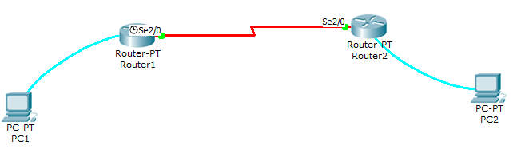



✓

1. Open a HyperTerminal session on each PC and establish a session to the respective router and type the following commands

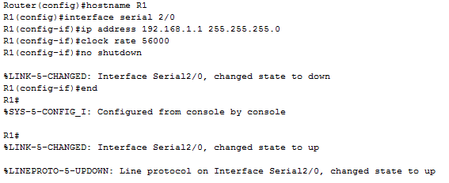

 ✓

1. Now repeat for the same process for the second router (as below)

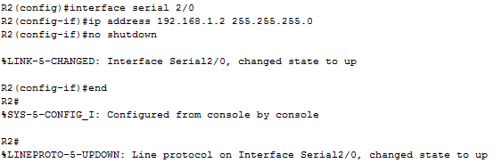

 ✓

1. On Router1, issue the show interface serial 2/0to view the encapsulation type.

What is the encapsulation type? _____**HDLC**_______________

Repeat the same show command on R2.

What is the encapsulation type? _____**HDLC**_______________

1. From Router2, ping Router1 to test connectivity.

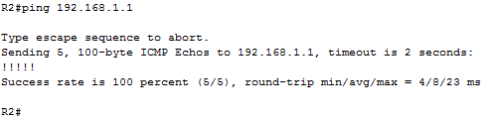



✓

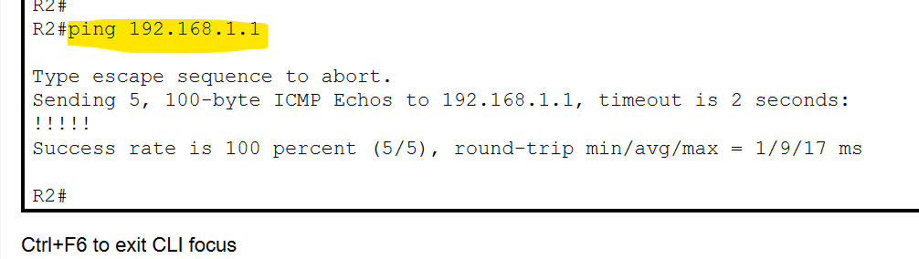

1. Change the encapsulation type to PPP

Enter the following commands to change the encapsulation type on the connecting serial interfaces of both routers to PPP.

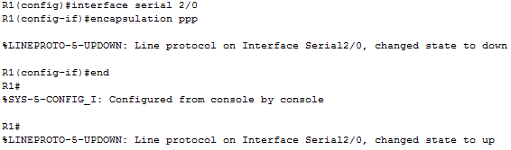

 ✓

1. Now repeat for the same process for the second router (as below)

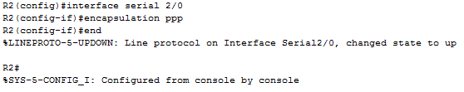

 ✓

1. On Router1, issue the show interface serial 2/0to view the encapsulation type.

What is the encapsulation type? ______**PPP**______________

Repeat the same show command on R2.

What is the encapsulation type? ______**PPP**______________

Can the serial interface on Router2 be pinged from Router1? _**YES**_________

Can the serial interface on Router1 be pinged from Router2? __**YES**________

If the answer is no for either question, troubleshoot the router configurations to find the error.

1. Configure PPP authentication on R1 with CHAP

Configure the CHAP username and password on the R1 router. The username must be identical to the hostname of the other router.

Both the password and usernames are case-sensitive. Define the username and password to expect from the remote router. On Cisco routers, the secret password must be the same for both routers.

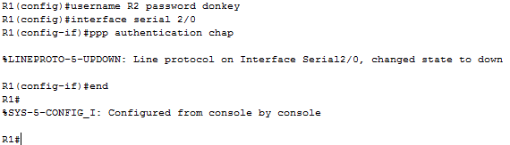

 ✓

1. Configure PPP authentication on R2 with CHAP

Configure the CHAP username and password on the R2 router. The passwords must be the same on both routers. The username must be identical to the hostname on the other router. Both the password and user names are case-sensitive. Define the username and password to expect from the remote router.

****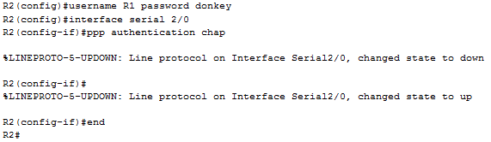

✓

1. Verify that the serial connection is functioning by pinging the serial interface of R1.

Was it successful? __**Yes**________

Why or why not?

**As the passwords in both router matched and the user names are provided respectively the connection between them is established as expected.**

